IAM task-01
- Create one IAM user and assign EC2 and S3 full access roles.

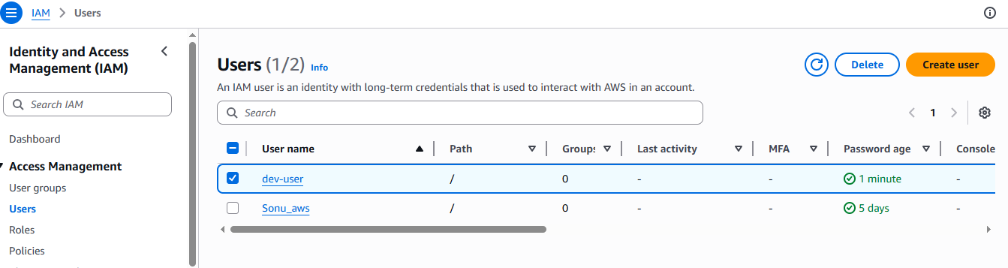

- Create one group in IAM and assign read access for EC2. 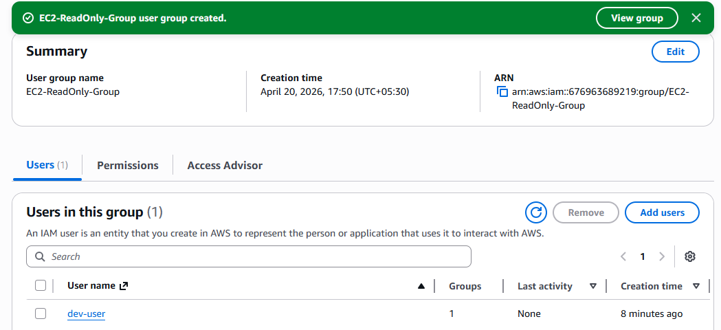
3. Create a new user named "Devops" and add to the group created in task 2. 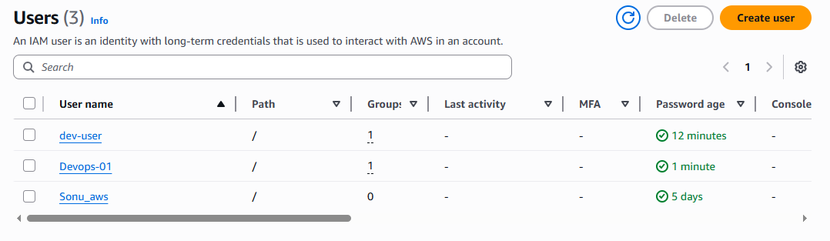

4. Write a bash script to create an IAM user with VPC full access. 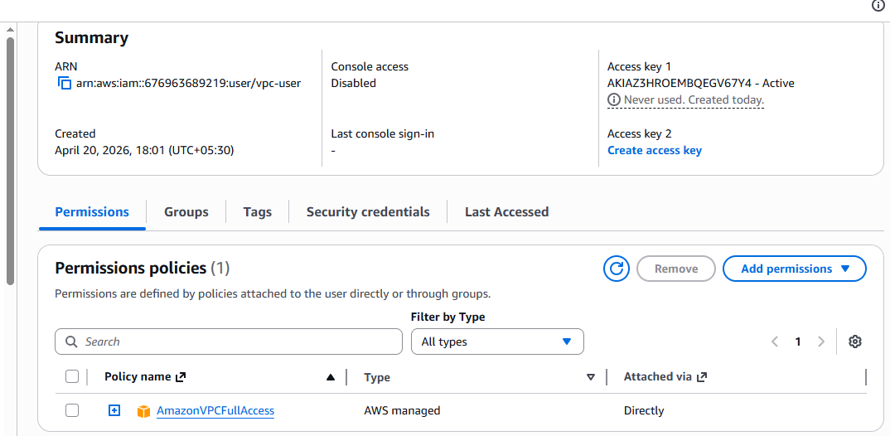
5. Create an IAM policy to allow EC2 access for a specific user in specific regions only. 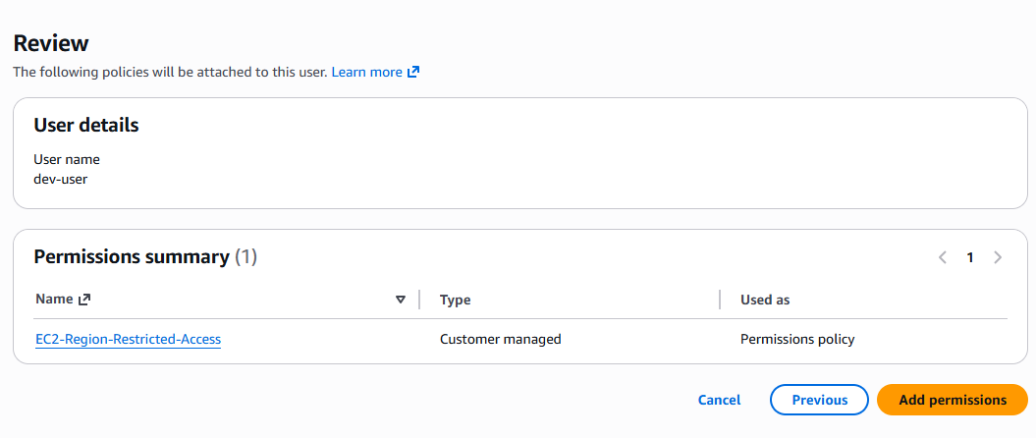 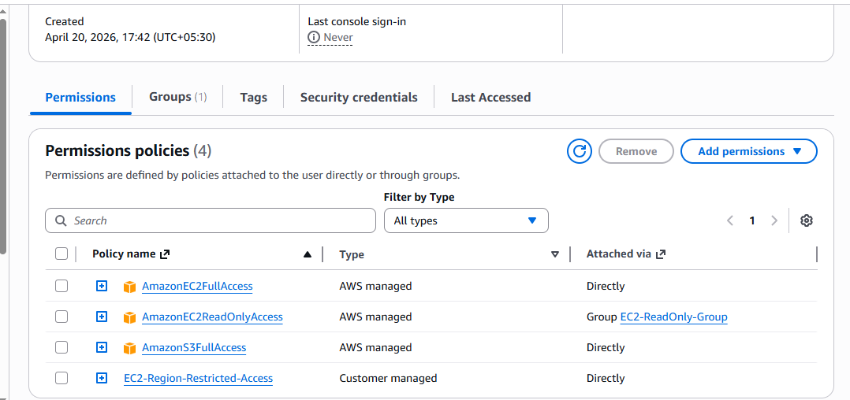
6. We have two accounts: Account A and Account B. Account A user should access an S3 bucket in Account B.
